**Homework 4 Hardcopy – 520 / 002**

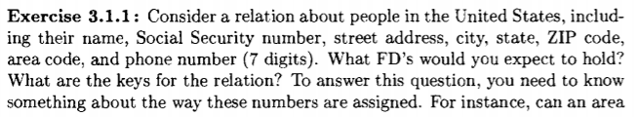3.1.1 –

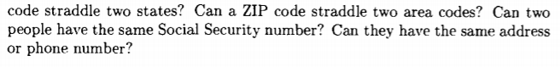

Relation: PeopleUS(name, ssn, address, city, state, zip, areaCode, phoneNum)

FD holds: ssn → name address city state zip areaCode phoneNum

Social security numbers (ssn) are unique, and all other attributes in this relation can be functionally determined by a person’s ssn. While all the other attributes like name, address, city, state, zip, area code, and phone number could potential be repeated to identify a person.

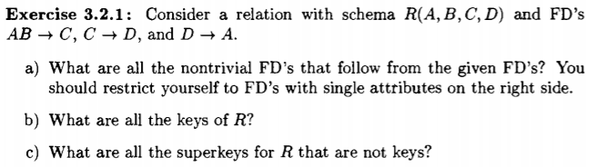

3.2.1

1. FD’s: AB → C, C → D and D → A

Nontrivial FD’s: AB → D and C → A

1. The keys of R are {A, B} because A and B can functionally determine all the remaining attributes in the relation.
2. The superkeys for R that are not keys are; {A, B, C}, {A, B, D}, and {A, B, C, D}.



3.2.2(ii)



1. FD’s: AB → C, BC → D, CD → A, and AD → B

Nontrivial FD’s: AB → D, BC → A, CD → B, and AD → C

1. The keys of R are {A, B}, {B, C}, {C, D}, and {A, D}.
2. The superkeys of R are {A, B, C}, {B, C, D}, {A, C, D}, {A, B, D}

and {A, B, C, D}.

3.2.4

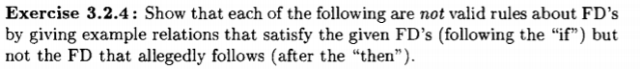



Considering phone numbers to names we could make the relation:

PhoneCompany( phoneNumber, name )

And we could say:

A = phoneNumber

B = name

Since phone numbers are unique, A → B is valid. But, because names are not always completely unique, and people could have the same name, B → A would not be valid.



Considering the relation:

School( studentID, name, classTaken )

And we could say:

A = studentID

B = name

C = classTaken

Since student ID’s are unique and an ID and name could correctly determine if a class is taken, AB → C is valid. A student ID being unique could also individually determine a class taken by a student, thus A → C. But, because names are not always completely unique, and people could have the same name, B → C would not be valid.



Considering the relation:

School( className, studentID, classGrade )

And we could say:

A = className

B = studentID

C = classGrade

Since a class name and a student ID can be used to determine a student’s class grade we can see, AB → C is valid. But, because a class name or student ID individually can’t determine a class grade, A → C or B → C would not be valid.

3.2.10(a,c)­ 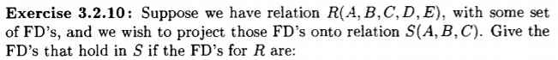

FD’s that hold in S: AB → C and C → A.



FD’s that hold in S: AC → B and A BC → A.

3.3.1(b,d)



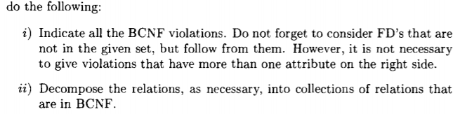



1. BCNF violations: Since B cannot be determined as a key, we can assume that both B → C and B → D violate BCNF.
2. Decomposition: B → D = {B, C, D}

$$R_{1 }\left(B, C, D\right) and R_{2 }\left(A, B\right)$$

In the first relation we can determine that it is in BCNF because B is the key for C and D. Since there are no FD’s between A and B we can also say that the second relation is in BCNF.

Collections of relations that are in BCNF: {B, C, D} and {A, B}



1. BCNF violations: Since we could say that A, B, C, and D can all be keys, then we could say that the relation violates BCNF.
2. Decomposition: none

Collections of relations that are in BCNF: none

3.3.4

